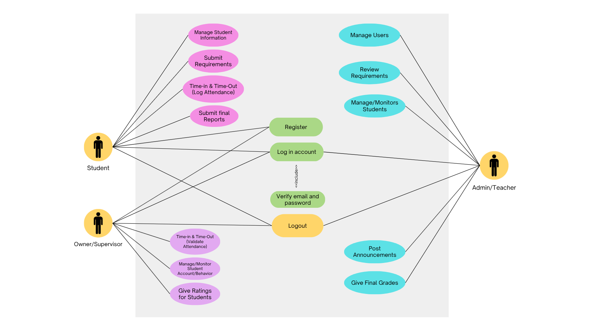
Work Immersion Monitoring System
Use Case Diagram (UCD)

Manage Student Information
Work Immersion Monitoring System
Data Flow Diagram (DFD)

Submit Requirements
Login Process
Register

Student

Give Final Grade
Review requirements
Approve and Reject
Login

Give rating for Students
Manage/Monitor Student Account/Behavior

Admin/Teacher
Login
Register

Owner/Supervisor

Time-in and Time-Out
Submit Reports
